1. Explain the heap property of a tree

The parent node always has a value larger than its child node.

2. List and describe the 3 methods most often associated with a stack.

Pop() – Removes and returns the top item of the stack

Push() – Adds item to the top of the stack

Peak() – Returns the top item of the stack without returning

3. Identify 3 errors in the following code snippet:

num = input()

def factorial[n]:

if n == 0:

return 1;

else:

return n * factorial(n-1)

num(factorial)

4. Suppose there are 2 circles on a cartesian plane at (1,1) and (4,1), with a radius of m and n respectively. Write pseudocode that determines if the two circles overlap.

Find the distance of each point from (1, 1) and (4, 1) (Distance = sqrt ((x2-x1)^2 + (y2-y1)^2))

If both distances are equal or less than (m+n):

Then the circles overlap

Let (x, y) = currentPoint

If sqrt((x-1)^2 + (y-1)^2)) <= 6 AND sqrt((x-4)^2 + (y-1)^2)) <= 6:

Overlap = True

5. Use pseudocode to design a class that represents a car.

def class Car:

def __init__(self, make, model, year, mpg, hp):

self.make = make

self.model = model

self.year = year

self.mpg = mpg

self.hp = hp

def drive(self, destination):

def direction(self)

def stop(self)

6. Explain the meaning and use of the global keyword in python

Allows all classes, methods, functions to access this variable

7. Draw a binary search tree containing the items added in order of [14, 5, 21, 3, 7, 8, 9, 1, 12]:

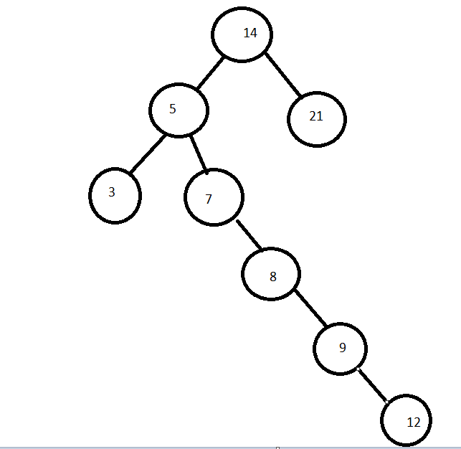

8. Give the Big-O performance of the following code fragment:

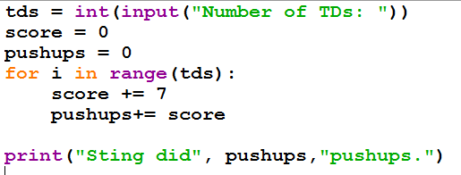

O(n)

9. Give the Big-O runtime of the following code snippet:

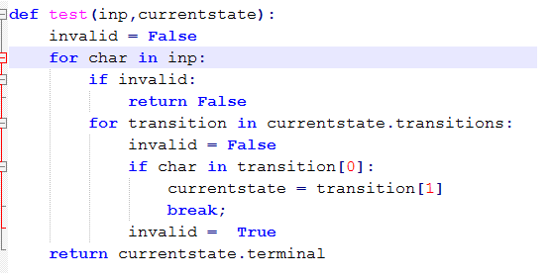

O(n^2)

10. Write a python program that uses **a dictionary** to store the following states and capitals.

Des Moines, Iowa  
Jefferson City, Missouri  
Albany, New York  
Sacramento, California  
Austin, Texas  
Lincoln, Nebraska

Finally, print the capital of California from your dictionary.  
  
stateCapitals = {"Des Moines":"", "Jefferson City":"", "Albany":"", "Sacramento":"", "Ausitn":"", "Lincoln":""}

def addStates(num):

for entry in stateCapitals:

if stateCapitals[entry] == "":

stateCapitals[entry] = num

break

addStates("Iowa")

addStates("Missouri")

addStates("New York")

addStates("California")

addStates("Texas")

addStates("Nebraska")

for entry in stateCapitals:

if stateCapitals[entry] == "California":

print(entry)

11. Define the following terms in the context of computer science:

a. Complexity – a way of measuring the runtime of an algorithm

b. Heuristic – a shortcut for an otherwise challenging problem; reduces an algorithm

c. Linear – linear algorithms runs through their data set once

d. Tree – a linear data structure used to stimulate data with a root value, subtrees, and nodes

e. Stack – a linear data structure that stores the most recent item added as the first item in the list

f. Node – a point/value on a tree

g. Graph – a graph is a structure to represent data

h. Queue – a linear data structure that stores items in the order they are added; first in first out

i. Quadratic – quadratic algorithms are ones to have a runtime of n^2

j. Exception – an exception is an error that is caught by the code

k. Dictionary – a linear data structure that stores a list of items with a keyword